**1441 - Egypt**

**Description**

A long time ago, the Egyptians figured out that a triangle with sides of length 3, 4, and 5 had a right angle as its largest angle. You must determine if other triangles have a similar property. 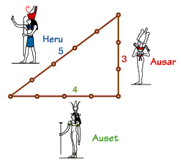

**Input specification**

Input represents several test cases, followed by a line containing 0 0 0. Each test case has three positive integers, less than 30000, denoting the lengths of the sides of a triangle.

**Output specification**

For each test case, a line containing "right" if the triangle is a right triangle, and a line containing "wrong" if the triangle is not a right triangle.

**Sample input**

6 8 10

25 52 60

5 12 13

0 0 0

**Sample output**

right

wrong

right

**Hint(s)**

|  |  |
| --- | --- |
| Statistics | **sub:**[2140](http://coj.uci.cu/24h/status.xhtml?abb=1441)| **ac:**[1025](http://coj.uci.cu/24h/status.xhtml?abb=1441&status=ac)|**ac%:** 47,90 |**score:** 0,20 |
| Created by | Waterloo Local Contest 2010 October 2 |
| Added by | [ejaltuna](http://coj.uci.cu/user/useraccount.xhtml?username=ejaltuna) |
| Addition date | 2011-10-13 |
| Time limit (ms) | 1000 |
| Memory limit (kb) | 65536 |
| Output limit (mb) | 64 |
| Size limit (bytes) | 100000 |
| Enabled languages | Bash | C | C# | C++ | Java | Pascal | Perl | PHP | Python | Ruby | Text |